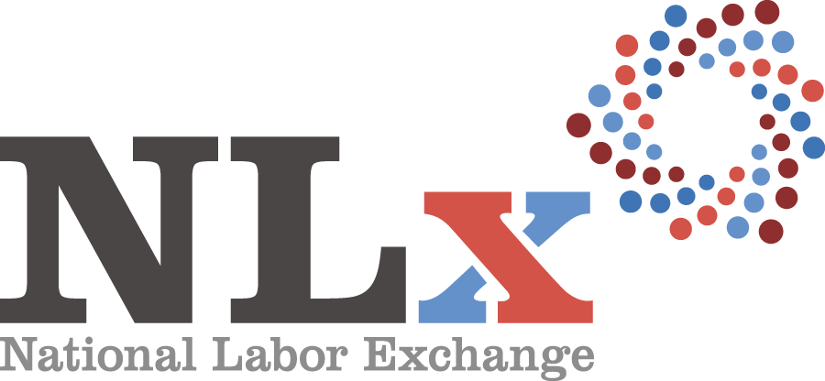 AGENDA

Tuesday, November 7, 2017
Location: | Sheraton Lake Buena Vista Resort, Orlando, FL
Attendees: | NLx Steering Committee and Technology Committee

7:30 a.m. – 8:30 a.m. | Full Breakfast (hosted)
8:30 a.m. – 8:45 a.m. | Welcome & Introductions  - Neil Adcox, South Carolina, Chair, NASWA Technology Committee  - Pam Gerassimides, Assistant Executive Director & Workforce Technology Director, NASWA  - Candee Chambers, Executive Director, DE  - Charlie Terrell, NLx Steering Committee Co-Chair, NLx Assistant Director, NASWA  - Jen Polcer, NLx Steering Committee Co-Chair, VP of Compliance, DE
8:45 a.m. – 9:00 a.m. | National Initiatives & Partnership Update & Discussion  - Charlie Terrell, NLx Steering Committee Co-Chair, NLx Assistant Director, NASWA
9:00 a.m. – 9:45 a.m. | Workforce Information Technology Center Discussion & Update  - Pam Gerassimides, Assistant Executive Director & Workforce Technology Director, NASWA
9:45 a.m. – 10:15 a.m. | LinkedIn Update  - Nate Williams, Public Sector Initiatives, LinkedIn – via phone
10:15 a.m. – 10:30 a.m. | Break!
10:30 a.m. – 11:00 a.m. | Peer-to-Peer Exchange
11:00 a.m. – 12:00 p.m. | NLx Data Projects Update: LMI Institute Study  - Pam Gerassimides, Assistant Executive Director & Workforce Technology Director, NASWA  - Ken Poole, CEO/President, Center for Regional Economic Competitiveness  - William Cook, Research Analyst/Web Developer, Center for Regional Economic Competitiveness
12:00 p.m. – 1:15 p.m. | Joint Lunch (Hosted)
1:15 p.m. – 3:00 p.m. | NLx Operations Update & Discussion  - Christy Merriman, NLx Operations Manager, DE  - Emma Northcott, NLx Program Analyst, NASWA  - Lori Adams, Policy Director & NLx Senior Advisor, NASWA
3:00 p.m. – 3:15 p.m. | Break!
3:15 p.m. – 5:00 p.m. | DirectEmployers Update & Discussion  - Partnerships: Shannon Offord, Manager, Strategic Partnerships, DE  - Digital Strategies: Heather Hoffman, VP of Digital Strategies, DE – via phone  - Membership: Tom Eckhart, VP Membership Development, DE
6:30 p.m. | Dinner  - Reservation at Johnnie’s Hideaway, 12551 FL-535, Orlando, FL

Wednesday, November 8, 2017
Attendees: | NLx Steering Committee

7:30 a.m. – 8:30 a.m. | Full Breakfast (hosted)
8:30 a.m. – 9:00 a.m. | Welcome Back & Overview of Strategy Session  - Charlie Terrell, NLx Steering Committee Co-Chair, NLx Assistant Director, NASWA  - Jen Polcer, NLx Steering Committee Co-Chair, VP of Compliance, DE
9:00 a.m. – 10:15 a.m. | Strategic Planning & Communications Discussion
10:15 a.m. – 10:30 a.m. | Break!
10:30 a.m. – 11:30 a.m. | Strategic Planning & Communications Discussion (continued)
11:30 a.m. – 12:00 p.m. | Peer-to-Peer Exchange

Safe Travels Home Everyone!

Save the Date:
NLx Steering Committee Meeting
March 26-28, 2018
Savannah, GA
More details to come!

