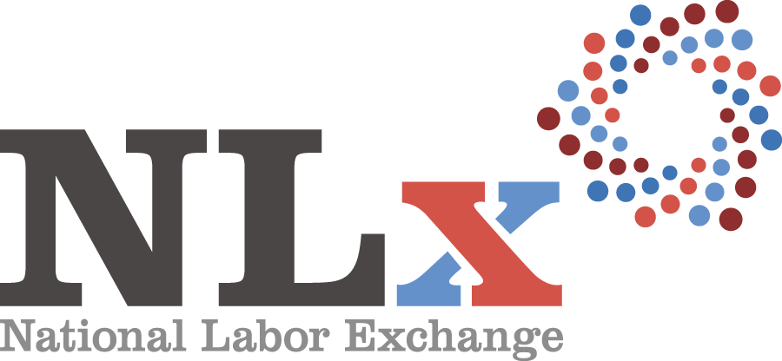 AGENDA
Wednesday, October 10, 2018
Carina Room
The Line Hotel
1770 Euclid St NW
Washington, DC 20009

7:30 a.m. – 8:30 a.m. | Breakfast (Hosted)
8:30 a.m. – 8:50 a.m. | Welcome & Introductions  - Charlie Terrell, NLx Steering Committee Co-Chair, NLx Director, NASWA  - Shannon Offord, NLx Steering Committee Co-Chair, VP Strategic Partnerships & Alliances, DE
8:50 a.m. – 9:10 a.m. | NASWA Update  - Scott Sanders, Executive Director, NASWA
9:10 a.m. – 9:30 a.m. | DirectEmployers Update  - Candee Chambers, Executive Director, DE
9:30 a.m. – 10:15 a.m. | Federal Partnerships & National Initiatives Update  - Charlie Terrell, NLx Steering Committee Co-Chair, NLx Director, NASWA  - Shannon Offord, NLx Steering Committee Co-Chair, VP Strategic Partnerships & Alliances, DE  - Lori Adams, Policy Director & NLx Senior Advisor, NASWA
10:15 a.m. – 10:30 a.m. | Break
10:30 a.m. – 11:00 a.m. | LinkedIn Update & Discussion  - Efrem Bycer, Economic Graph Manager, LinkedIn
11:00 a.m. – 11:45 a.m. | State Survey Update & Discussion  - Charlie Terrell, NLx Steering Committee Co-Chair, NLx Director, NASWA  - Emma Northcott, Program Analyst, NASWA
11:45 a.m. – 1:15 p.m. | Working Lunch (Hosted)  - Lori Adams, Policy Director & NLx Senior Advisor, NASWA  - Mark Toal, National Veterans’ Employment Manager, USDOL-VETS
1:15 p.m. – 1:45 p.m. | USDOL Office of Apprenticeship Update  - Charlie Terrell, NLx Steering Committee Co-Chair, NLx Director, NASWA  - Shannon Offord, NLx Steering Committee Co-Chair, VP Strategic Partnerships & Alliances, DE  - Lori Adams, Policy Director & NLx Senior Advisor, NASWA  - Kevin Fitzpatrick, Manager, Booz Allen Hamilton  - Tita Brett, Lead Associate, Booz Allen Hamilton
1:45 p.m. – 2:15 p.m. | Roundtable Discussion  - Charlie Terrell, NLx Steering Committee Co-Chair, NLx Director, NASWA  - Shannon Offord, NLx Steering Committee Co-Chair, VP Strategic Partnerships & Alliances, DE
2:15 p.m. – 2:45 p.m. | NLx Data Projects Update: University of Chicago  - Charlie Terrell, NLx Steering Committee Co-Chair, NLx Director, NASWA  - Emma Northcott, Program Analyst, NASWA
2:45 p.m. – 3:00 p.m. | Break!
3:00 p.m. – 3:20 p.m. | Virtual Jobs Update  - Christy Merriman, NLx Operations Manager, DE  - Emma Northcott, Program Analyst, NASWA  - Samantha Teh, Program Manager, Utah Department of Workforce Services
3:20 p.m. – 4:00 p.m. | NLx Operations Update & Discussion  - Christy Merriman, NLx Operations Manager, DE  - Emma Northcott, Program Analyst, NASWA  - Lori Adams, Policy Director & NLx Senior Advisor, NASWA
4:00 p.m. – 5:00 p.m. | Employer Update & Discussion  - Shannon Offord, NLx Steering Committee Co-Chair, VP Strategic Partnerships & Alliances, DE  - Christy Merriman, NLx Operations Manager, DE  - Colin Seal, Public Affairs Manager, Grifols
6:30 p.m. | Dinner (Hosted)  - A Rake’s Progress, The Line Hotel

Thursday, October 11, 2018

8:00 a.m. – 9:00 a.m. | Breakfast (hosted)
9:00 a.m. – 10:00 a.m. | U.S. Chamber of Commerce Foundation Update & Discussion  - Jason Tyszko, Vice President, Center for Education and Workforce, U.S. Chamber of Commerce Foundation
10:00 a.m. – 10:15 a.m. | Break
10:15 a.m. – 11:15 a.m. | Communications Discussion  - Charlie Terrell, NLx Steering Committee Co-Chair, NLx Assistant Director, NASWA  - Shannon Offord, NLx Steering Committee Co-Chair, VP Strategic Partnerships & Alliances, DE  - Teri O’Neal, Director of Public Relations, A. Bright Idea
11:15 a.m. – 12:00 p.m. | Peer-to-Peer Exchange

Safe Travels Home Everyone!

