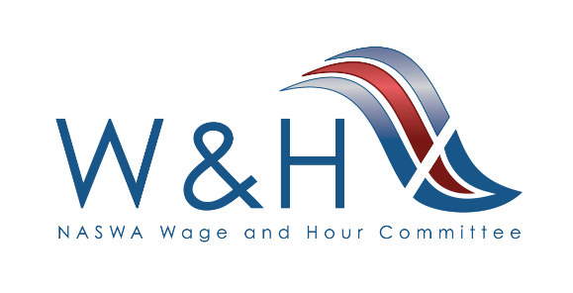
W&H Committee Meeting
September 9, 2025 | Dallas, TX
Hilton Anatole
Manchester (Mezzanine Level)

Tuesday, September 9th
7:30 – 8:30 am Hosted Breakfast Trinity Prefunction Area – Lobby Level

Meeting Room: Manchester (Mezzanine Level)

8:30 – 8:45 am Welcome & Introductions

- Ellen Saline, Wage & Hour Committee Chair, Senior Policy Manager, Washington State Department of Labor and Industries
- David Biglin, Wage & Hour Committee Vice-Chair, Deputy Assistant Commissioner, Wage & Hour Compliance, New Jersey Department of Labor & Workforce Development

- Texas Welcome
  - Anna Colbert, Texas Workforce Commission

8:45 – 9:15 am State Spotlight Presentation

- Texas Workforce Commission
  - Anna Colbert, Director, Wage and Hour Department

9:15 – 9:30 am State Workforce Organizations Update

- Interstate Labor Standards Association (ILSA)
  - Ellen Saline
- National Association of Government Labor Officials (NAGLO)
  - Ethel Belfon

9:30 – 10:00 am State Roundtable
One member from each state:
- Reports on one recent accomplishment
- Shares one question or area of interest you hope to connect with your colleagues about.

10:00 – 10:30 am Networking Break

10:30 am – 12:00 pm State Spotlight Presentations

- Alaska Department of Labor and Workforce Development
  - Tanya Keith, Director, Labor Standards and Safety Division

- New Jersey Department of Labor and Workforce Development
  - David Biglin, Deputy Assistant Commissioner, Wage & Hour Compliance
  - Joe Petrecca, Assistant Commissioner, Wage & Hour Compliance
  - Toni Longo, Director, Public Contracts and Construction

12:00 – 1:30 pm Hosted Lunch Trinity Prefunction Area – Lobby Level

1:30 – 2:15 pm State Roundtable cont.
One member from each state:
- Reports on one recent accomplishment
- Shares one question or area of interest you hope to connect with your colleagues about.

2:15 – 3:00 pm State Spotlight

- Washington State Department of Labor and Industries
  - Ellen Saline, Senior Policy Manager

3:00 – 3:30 pm NETWORKING BREAK

3:30 – 4:15 pm State Spotlight

- Hawaii Department of Labor & Industrial Relations
  - Jaquilyn Naanos, Investigations Section Supervisor, Compliance Branch, Wage Standards Division

4:15 – 4:50 pm Committee Business

- Topics of Interest
- Next Meeting

4:50 – 5:00pm Gavel Transition

5:00 pm Wrap-Up and Adjournment

5:30 – 7:00 pm Welcome Reception Trinity Exhibit Hall – Lobby Level

